Memorial Middle School
Reading Olympics
2014
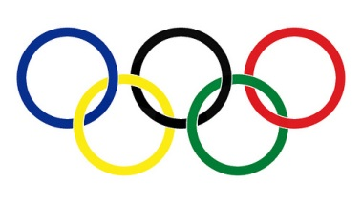
Graphic Novel
To earn a gold medal for Graphic Novels you must read one of each:
manga novelization history comic
biography superhero science choice

Title: ____________________________________ Author: ____________________________________

Title: ____________________________________ Author: ____________________________________
You’ve earned a Bronze!
Title: ____________________________________ Author: ____________________________________

Title: ____________________________________ Author: ____________________________________

Title: ____________________________________ Author: ____________________________________
You’ve earned a Silver!
Title: ____________________________________ Author: ____________________________________

Title: ____________________________________ Author: ____________________________________

Title: ____________________________________ Author: ____________________________________
You’ve earned a Gold!!!

